|  |  |  |  |  |
| --- | --- | --- | --- | --- |
|  | **Solution Design Document**   |  | | --- | | **RBSC Tile on Launchpad** | |  | | |
|  | Jira (Epic) | Build up tiles on SAP launchpad for RBSC business transactions |
|  | Project ID | [ITSEC2017-6260](https://jira.tools.sap/browse/ITSEC2017-6260) |
|  | Classification | Confidential |
|  |  | |

Table of contents

1 General Information 6

1.1 Document History (Mandatory) 6

1.2 Approval Steps (Mandatory) 7

1.3 Related Documents / Jira objects 7

1.4 Glossary 8

2 Business Refinement (Part I) 9

2.1 Description 9

2.2 Stakeholders 9

2.3 Business value & priority 9

3 Solution Requirements 10

3.1 High level description 10

3.2 Business process overview 10

3.2.1 Process description 10

3.2.2 Process diagram/flow 10

3.3 Process improvements compared to as-is (summary) 10

3.4 High-Level Requirements 10

3.5 Test scenarios (FAT) 11

4 Solution Design (Part II) 12

4.1 Solution overview 12

4.2 Assumption 12

4.3 Solution Architecture / Design 12

4.3.1 Standard products/service/customizing 12

4.3.2 Custom development (Enhancements) 12

4.4 Solution details 12

4.4.1 Customizing Tables 12

4.4.2 Application Tables 13

4.4.3 User Dialog Interface / Screens 13

4.4.4 Authorization approach 13

4.4.5 Reports / reporting 13

4.4.6 Interfaces 13

4.5 Language requirements 14

4.6 System impact 14

4.7 Performance / transaction volume requirements 14

4.8 Dependencies / constraints 14

4.9 Open Points 14

5 Go-Live tasks (Part III) 15

5.1 Pre Go-Live activities 15

5.1.1 Migration of Master data 15

5.1.2 Migration of Application data 15

5.2 Go-Live activities 15

5.3 Post Go-Live activities 15

6 Appendix 16

Table of Figures

Figure 1 Emergency / Fall back process 13

Figure 2 Master data check to be considered 14

Figure 3 Re-Check logic 14

Figure 4 [E741-DIAG-01a] Process Overview 16

Figure 5 [E741-DIAG-01b] Flow Diagram 17

Figure 6 Include /SAPSLL/LCD_PI_R3F00 18

Figure 7 Copy control functions 18

Figure 8 Include RV45B945 19

***Purpose of this Template:***

*This template is used to document the* ***results of the user story/business requirement grooming****.*

*It will be written by the IT PO and/or team members, who were part of the grooming meeting.*

*It should explain the* ***WHY:***

* + - *What is the business context?*
    - *Who is this for?*
    - *What are the goals?*
    - *What is the business value?*

*the* ***WHAT:***

* + - *What is the expected end result of the item?*
    - *When would it be accepted? (Acceptance criteria)*
    - *What do the Users and Stakeholders want to see during the Sprint Review meeting?*

***in just enough detail, so that IT can say: Yes, we got it and can start working on it.***

*and in a later step the* ***HOW****:*

* + - *How could the high level technical design look like?*
    - *What additional information is necessary?*
    - *Who/which teams need to be involved additionally for the next steps*

*This document will be the base for the planning with the IT Scrum team and will document the solution together with the TDD (Technical Design Document).*

# General Information

## Document History (Mandatory)

*Whenever information gets changed in the document, a new version must be added. We do not need a new version if we just do spelling correction, grammar corrections, etc.*

*Information examples:*

* *Adjustments in user story, resulting in* 
  + *new or changed requirements*
  + *new changed process flow*
  + *etc.*
* *Adjustments to anything in the detailed chapters*

*Note: When unsure, add a new version and describe the changes.*

| Version | Date | Editor | Revision description |
| --- | --- | --- | --- |
| 0.1 | 09.08.2022 | Lisa Villinger | Initial Version |
|  |  |  |  |
|  |  |  |  |
|  |  |  |  |

*How to number the versions*

*Part I: Business alignment (mostly work on chapter 2/3):*

*0.1 – 0.8 Draft (user story / business process)*

*0.9 Ready for (business) review, Reviewer: User Story Owner / Business PO*

*0.91 – 0.9x Implement review comments*

*1.0 Alignment with business finalized (User Story and chapters 2/3 are all in sync)*

*Part II: High-level Solution Design (only work on chapter 4):*

*1.1 – 1.8 Draft (high-level design)*

*1.9 Ready for (technical/business) review, Reviewer: IT-PO*

*1.91 – 1.9x Implement review comments*

*2.0 Final document → handover to TDD*

*Part I / II: In case of relevant changes:*

*2.1 – 2.8 Draft*

*2.9 Ready for review, Reviewer: User Story Owner or Architect or IT-PO*

*2.91 – 2.9x Implement review comments*

*3.0 Final document*

*Example:*

| Version | Date | Editor | Revision description |
| --- | --- | --- | --- |
| *0.1* | *13.12.2019* | *<name of IT-PO>* | *Chapter 1 - 3 in process* |
| *0.9* |  | *<name of IT-PO>* | *Ready for review* |
| *1.0* |  | *<name of Business PO / IT-PO>* | *Reviewed and approved without comments* |
| *1.1* |  | *<name of Architect>* | *Chapter 4 in process* |
| *1.9* |  | *<name of Architect>* | *Ready for review* |
| *2.0* |  | *<name of IT-PO>* | *Reviewed and approved without comments* |
| *2.1* |  | *<name of Architect>* | *Chapter 4.4.3*  *- Req. xxx enhanced*  *Chapter 4.4.4*  *- OP.10 clarified*  *- Additional Reqs. xxx added* |

## Approval Steps (Mandatory)

*4 eyes principle needs to be ensured. Product Owner, Architect, etc.*

*All x.9 versions*

| Version | Date | Reviewer | Review comments |
| --- | --- | --- | --- |
|  |  |  |  |
|  |  |  |  |
|  |  |  |  |

## Related Documents / Jira objects

*List all the attachments in this document using the above table and refer the number wherever required.*

*Background explanation:*

*1..x User Stories (all related to the same EPIC) → 1 IT-Epic (it internal topics might not have an user story)*

*1 IT-Epic → 1..y SDD*

*1 SDD → 1..z TDD*

*How to define Reference IDs:*

|  |  |  |  |  |
| --- | --- | --- | --- | --- |
| *Object* | *Definition* | *Example* | *Type* | *Comment* |
| *User Story* | *[US + <last number of Jira Task>]* | *[US311]* | *Jira* | *based on Jira BPREXPCTRL-311* |
| *Epic* | *[E + <last numbers of Jira Task>]* | *[E741]* | *Jira* | *based on Jira ITSEC2017-741* |
| *SDD* | *[<IT-Epic reference id> + S + <consecutive number (2 digits)>]* | *[E741-S01]* | *docx* |  |
| *TDD* | *[<Full SDD reference id> + T + consecutive number (2 digits)]* | *[E741-S01-T01]* | *docx* |  |
| *Diagrams* | *[<IT-Epic reference id> + DIAG + consecutive number (2 digits) + a/b]* | *[E741-DIAG-01a]*  *[E741-DIAG-01b]* | *vsdx* | *‘a’ stands for the original file (e.g. MS Visio file)*  *‘b’ stands for the corresponding jpeg or png file* |
| *Excel file* | *[<IT-Epic reference id> + where it belongs to (optional) + X + consecutive number (2 digits)]* | *[E741-X01] or [E741-S01-X01]* | *xlxs* |  |
| *Test Cases* | *[<Full SDD reference id> + INT/FAT + consecutive number (2 digits)]* |  |  | *Use INT for Integration test cases, use FAT for Functional Acceptance test cases* |
| *Customizing* | *[<Full SDD reference id> + CUST + 01]* |  |  | *Also we can put this in the appendix!* |
| *…* | *Feel free to add other abbreviations based on your needs, e.g. Training documents, any PPT, Recordings, etc.*  *Documents stored on sharepoint need the Epic-Reference ID in the beginning (as seen above)* |  |  | *Abbreviations could be document type related (e.g. [PPT-01] ) or content related (e.g. [ETS-01] )* |

*References related to documents on sharepoint shall use the Reference ID as Prefix in the corresponding file names to identify them easily on the sharepoint. Examples:*

* *E741-S01 ERP EM Concept.docx*
* *E741-S01-T01 ERP EM Concept – API6800.docx*
* *E741-S01-T02 ERP EM Concept – CD_STATUS_GET.docx*
* *E741-S02 ERP EM Concept – GTS enhancements.docx*
* *E741-S02-T01 ERP EM Concept – GTS enhancements.docx*
* *E741-S01 ERP EM Concept.docx*
* *E741-DIAG-01a ERP EM Concept HighLevel Design.vsdx*
* *E741-DIAG-01a ERP EM Concept HighLevel Design.png*

*This way we can add multiple SDDs and TDDs and other documents to the same Epic within the same cluster on the sharepoint (eg. Cluster “ERP developments”) but still be able to identify clearly the relations.* ***File name shall not contain the [ and ] brackets, as they are not allowed in links within Jira.***

*Note: the examples above do not exist, they just shall explain the idea of the naming conventions.*

| ID | Type | Document | Doc. Version or last seen date | Location/Link to document |
| --- | --- | --- | --- | --- |
| 1 | Link | SAP Launchpad PROD |  | [Startseite (sap.com)](https://fiorilaunchpad.sap.com/sites#Shell-home) |
| 2 | Link | ITCM Export Tool PROD |  | [ITCM Export Tool (W71) (sap.com)](https://fiorilaunchpad.sap.com/sites#itcmexporttool-Display) |
| 3 | Link | SAP Launchpad TEST |  | [Startseite (sap.com)](https://fiorilaunchpad-qa.sap.com/sites#Shell-home) |
| 4 | Link | SAP Launchpad DEV |  | [Startseite (ondemand.com)](https://flpsandbox-br339jmc4c.dispatcher.int.sap.eu2.hana.ondemand.com/sites#Shell-home) |
|  |  |  |  |  |
|  |  |  |  |  |
|  |  |  |  |  |
|  |  |  |  |  |
|  |  |  |  |  |

## Glossary

| Abbreviation | Meaning | Comment |
| --- | --- | --- |
| ITCM | International Trade Control Management |  |
|  |  |  |
|  |  |  |
|  |  |  |
|  |  |  |
|  |  |  |

# Business Refinement (Part I)

*Idea collection to evaluate chapter 3. Not relevant for Chapter 4!*

## Description

*If changes are needed in course of the grooming, this should be adjusted by business directly within JIRA*

A tile to each business transaction is required on SAP Launchpad.

## Stakeholders

*Please provide a list of stakeholders and roles to be involved for this demand.*

*S*

Operations – User of business transactions and Export Tool

## Business value & prioritys

*Please provide the business value and priority of this user story*

Enter the Export Tool and related Business Transactions at one place - SAP Launchpad

# Solution Requirements

Who? → It-PO Responsibility

*This chapter is supposed to give a summary about the intension of this demand and covers the requirements from a user story. It shall be quick to read and understandable for none-experts. What is it intended to do? Which business issues will it solve? How will it be used to support the business and/or improve business results?* **Please no technical details in this chapter!**

## High level description

**This chapter must be maintained by the IT experts (IT-PO) to describe their understanding of the User Story.**

ITC has its own folder in SAP Launchpad à *ITC - International Trade Control – Export Management*

Currently there is one tile listed, the *ITCM Export Tool*.

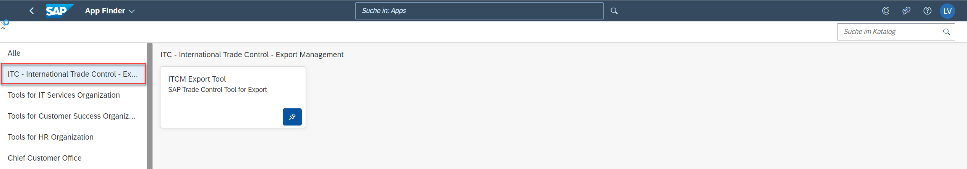

1. It is required to get a tile for test- and dev-landscape of ITCM Export Tool as well. Further the system must be displayed in the tile name in addition to distinguish between systems. – see mockup 4.3
2. It is required to build up the business transactions as tile in the ITC folder *ITC - International Trade Control – Export Management.* Each transactionneeds to build up as an own tile. Also for the business transactions we need one tile for one system (prod, test, dev). – see mockup 4.3

The intention is that the user (ECT) can work not only in backend but also on UI cloud to maintain licenses/ restricted customer/ rejected basket items.

Business transactions:

* Individual license release /ITCM/PV_POS
* Restricted customer release /ITCM/SPL_EXC
* Revoke rejected basket items /ITCM/ET_BASKET_UNDO

The tile must be set up equal to the business transaction.

To maintain individual license the user has to select for the customer (ERP business partner)

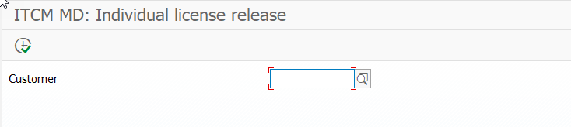

To maintain restricted customer the user has to select for the customer (ERP business partner). Further a check box exists to “show active licenses only”

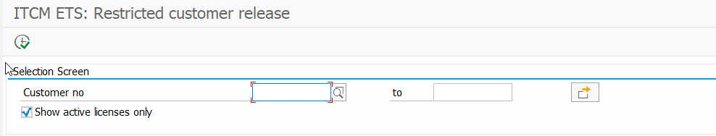

To revoke rejected licenses the user has to select for the Request ID

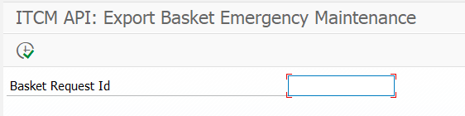

## Business process overview

### Process description

*Provide a description of the business process along with the variations of the process. If the variations are considerably high, consider creating a separate section for each variation. Start with the as-is process and evaluate the to-be process based on missing process and/or faulty process*

| Process Characteristics | |
| --- | --- |
| Process Trigger | Shipment channel request in ITCM Export Tool |
| Process Input | Individual maintenance of items/customer in Launchpad Tile/ I7/W7 transaction |
| Process Output | Status update ITCM Export Tool |
| Process Owner | ITC |
| Process Volumes |  |
| Process Frequencies | daily |
| Process Roles | ITC, Operations |

### Process diagram/flow

*Please show in a process flow the gaps in the as-is process (missing process/faulty process) and the required new process.*

## Process improvements compared to as-is (summary)

*Please summarize the improvements and estimate the business benefits*

## High-Level Requirements

*Please split in functional packages derived from the discussion, if they have different priorities (must/could/should) think about if a split of the user story makes sense; Team & Tasks gives an indication on who needs to be involved for the implementation.*

| Req. ID | Requirement Description | Scope | Comment |
| --- | --- | --- | --- |
| R1 | Create a tile for Individual license release |  |  |
| R2 | Create a tile for Restricted customer release |  |  |
| R3 | Create a tile for Revoke rejected basket items |  |  |
| R4 | Create tiles (Export Tool and Business Transactions) for each system PROD, TEST, DEV |  |  |
| R5 | New created and changed data must be in sync between I7/W7 transaction and related Launchpad tile |  |  |
|  |  |  |  |
|  |  |  |  |
|  |  |  |  |
|  |  |  |  |
|  |  |  |  |

## Test scenarios (FAT)

*IT-PO ensures that Business has created their test scenarios within the user story.*

| Test ID | Systems (from **→** to) | Test Scenario | Short Description |
| --- | --- | --- | --- |
| T1 | UI (I7/W7) | Individual license release UI | * Create individual license in ET UI * Check update in UI * Maintain entry in UI * Check update in I7/W7 transaction * Maintain entry in I7/W7 transaction * Check update in UI * Check update in ET UI   INT ExportTool_006 to be updated |
| T2 | UI (I7/W7) | Restricted customer release in UI | * Set ET5* category in ET UI * Check update in UI * Maintain entry in UI * Check update in I7/W7 transaction * Maintain entry in I7/W7 transaction * Check update in UI * Check update in ET UI   INT ExportTool_005 to be updated |
| T3 | UI (I7/W7) | Revoke rejected license in UI | * Reject an item in ET UI * Check update in UI * Maintain entry in UI * Check update in I7/W7 transaction * Maintain entry in I7/W7 transaction * Check update in UI * Check update in ET UI   INT RBSC_04 to be updated |
|  |  |  |  |
|  |  |  |  |
|  |  |  |  |
|  |  |  |  |
|  |  |  |  |

# Solution Design (Part II)

Who? → Development Team (Architect) Responsibility

## Solution overview

Here is the list of application tiles which will be visible on respective (dev, test, prod) instance of Fiori launchpad under the category: “ITC - International Trade Control – Export Management”

1. ITCM Export Tool
2. ITCM Revoke rejected basket items
3. ITCM Restricted customer release
4. ITCM Individual license release

Each of the application tiles will have system ID in brackets in the name indicating which backend system the application is connected to.

## Assumption

1. All the applications will be deployed on BTP (Business Technology Platform) which is necessary for communication and access to cloud connectivity.

Note:

Currently, only “ITCM Export Tool” application is deployed on BTP platform therefore, there is a need to perform the relevant development and configuration activity for the other applications.

1. Cloud connectors will be configured to exchange the data with the related backend systems (in case of production using balanced web dispatching)

## Mockup

*In this chapter a mockup can be shared, to make it more understandable to the business team, what it would look like. Here an example mockup of the offline screening report.*

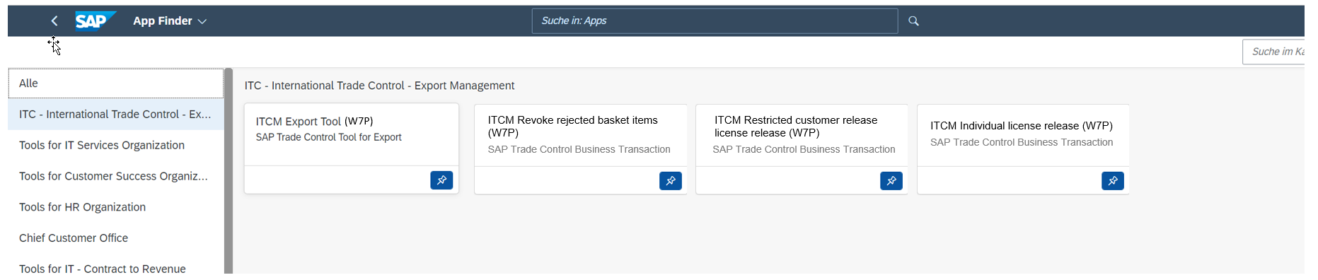

*SAP Launchpad ITCM PROD*

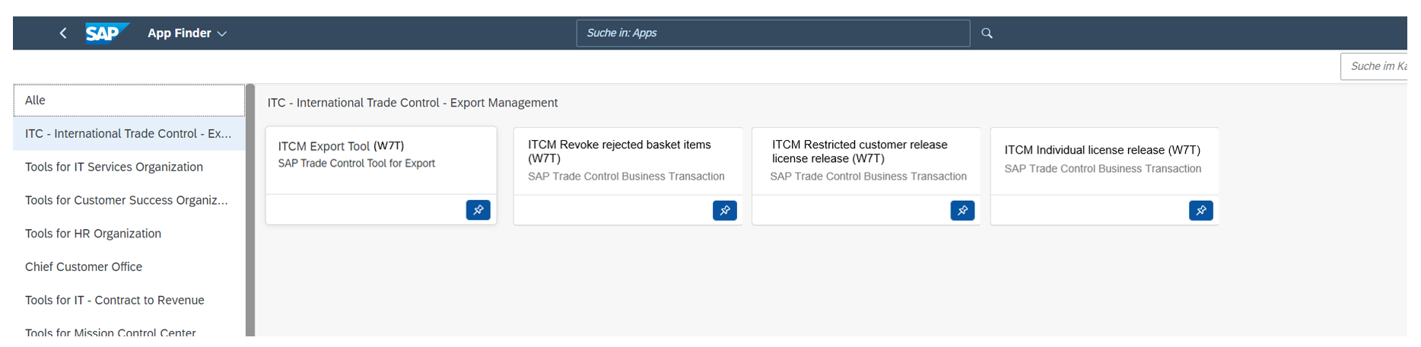

*SAP Launchpad ITCM TEST*

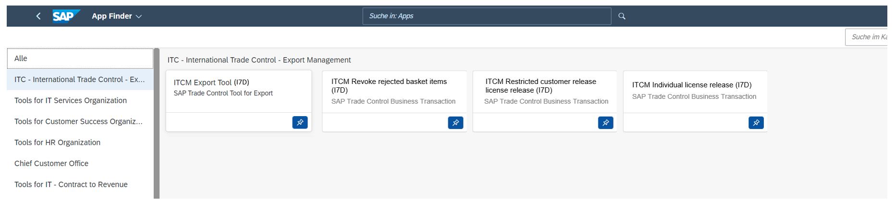

*SAP Launchpad ITCM DEV*

The new BTP Fiori applications should reflect the behavior of relevant ABAP transactions:

* Restricted customer release /ITCM/SPL_EXC
* Revoke rejected basket items /ITCM/ET_BASKET_UNDO
* Individual license release /ITCM/PV_POS

and should be implemented using smart filter and smart table controls supported by CDS views as below:

**ITCM Restricted customer release**   
There should be one page with the configurable selection criteria for the customer. By default, only “Customer” and “Show active licenses only” field will be visible  
 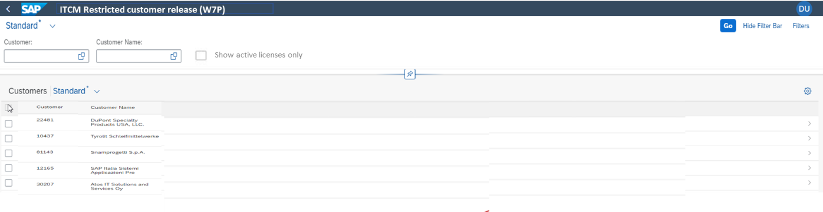

After making multiple selections for customers, the second page will contain detailed information and the buttons:

* Insert
* Edit
* Remove

Dialog windows for the above buttons will have the same information as in backend system. Confirming the operation on any dialog window will trigger the database update and the table refresh.  
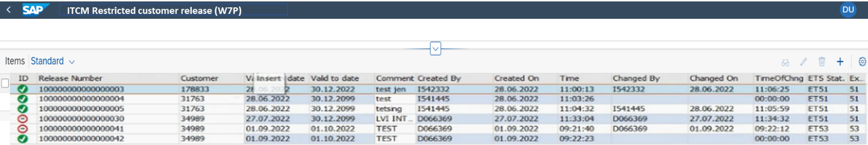

**ITCM Individual license release**

There should be one page for selection of the customer. By default, only “Customer” field will be visible  
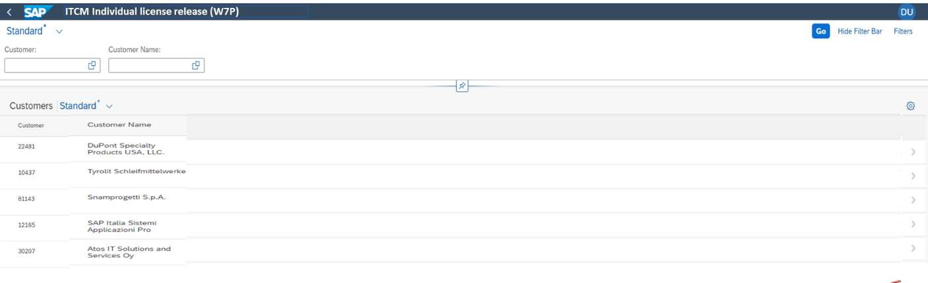

After selecting any customer, the next page should contain detailed information and the buttons:

* Add license
* Change license
* Revoke license

Dialog windows for the above buttons will have the same information as in backend system. Confirming the operation on any dialog window will trigger the database update and the table refresh.

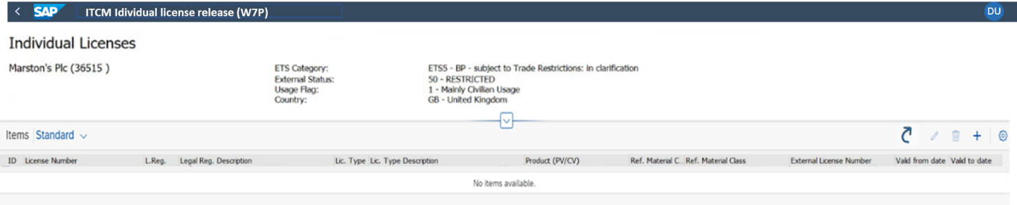

It should be also possible to navigate to the second page directly following the context of the Customer.

**ITCM Revoke rejected basket items**

There should be one page with the selection of the request. By default, only “Request” field will be visible

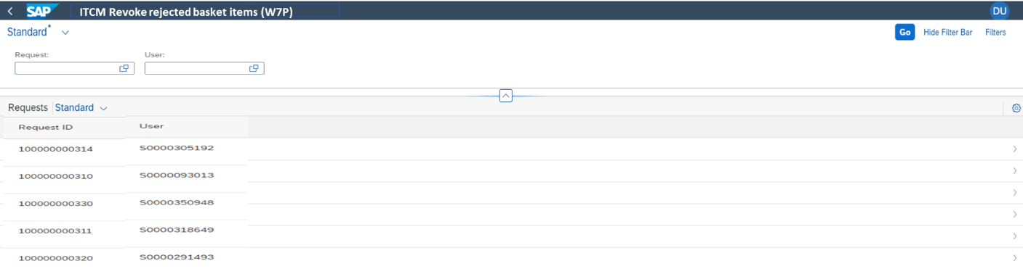

After selection of relevant request, the next page will contain detailed information and the button “Revoke” to revoke selected items:

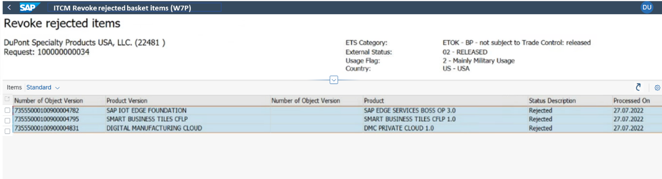

It should be also possible to navigate to the second page directly following the context of the request.

## Solution Architecture / Design

* Should API6800

### Standard products/service/customizing

*Please align anything written here with IT-PO.*

n/a

### Custom development (Enhancements)

## Solution details

### Customizing Tables

#### Req.ID title

*We need a general customizing table, to activate/deactivate the EM concept the EM cases. Therefore, we* *need to create a new table.*

|  |  |  |
| --- | --- | --- |
| Req. ID | Requirement Description | Comment |
| *ERP.030.00* | *Table attributes:*   * *customizing table (maintenance via SM30)* * *client dependent* |  |
| *ERP.030.10* | *Main columns:*   * *Activation flag* * *Threshold* |  |
| *ERP.030.20* | *A central table allows the activation of the emergency concept.* |  |
| *ERP.030.30* | *It shall be possible, to maintain a threshold (0..999). The threshold defines, when an EM case gets the status active and corresponding document references get stored in the table described in [ERP-010].* |  |
|  |  |  |

### Application Tables

#### ERP.010 Documents to be transferred with priority

*We need to store the documents, which need to be transferred with priority. Therefore, we need to create a new table.*

| Req. ID | Requirement Description | Comment |
| --- | --- | --- |
| *ERP.010.00* | *Table attributes:*  *application table*  *client dependent* |  |
| *ERP.010.10* | *Main columns:*  *Document number*  *Application level*  *Document type*  *Creation date/time*  *Change date/time* |  |
| *ERP.010.20* | *Only documents, that are marked in table /SAPSLL/TLER3B-CUSRV_R3 =”X” (activated for Trade Control checks) are relevant for recheck.* |  |
| *ERP.010.30* | *The doc transfer table shall store all document references, which were caught during missing RFC connection while the number of failed RFC calls is above the threshold* |  |
| *ERP.010.40* | *Documents, which were successfully transferred to GTS after RFC connection is available again, shall get a delete indicator* |  |
|  |  |  |

### User Dialog Interface / Screens

*We will add customizing view for:*

* *General settings of Emergency concept*
* *Denied Country list*
* *Eventually a new popup for user information (assumption right now: just adjust the message text in existing popup) - OOS*

### Authorization approach

n/a

### Reports / reporting

### Interfaces

n/a

## Language requirements

All texts visible to users must be available in German and English per default.

## System impact

n/a

## Performance / transaction volume requirements

n/a

## Dependencies / constraints

## Open Points

| Open Point ID | Open Point | Status |
| --- | --- | --- |
|  |  |  |
|  |  |  |
|  |  |  |

# Go-Live tasks (Part III)

*Who? → IT-PO / Component Owner / Architect Responsibility*

*Impact analysis→ define training required?, etc. --- to be discussed (with Isabel)*

## Pre Go-Live activities

| Step | System | Task | Short Description |
| --- | --- | --- | --- |
| *1* | *ERP* | *Maintain customizing* | *Enter denied countries (see [E741-S01-CUST01])* |
| *2* | *ERP* | *Migration* | *…* |
|  |  |  |  |
|  |  |  |  |
|  |  |  |  |
|  |  |  |  |
|  |  |  |  |
|  |  |  |  |

### Migration of Master data

### Migration of Application data

## Go-Live activities

## Post Go-Live activities

# Appendix